Workshop Molecular Photoreactivity on Metal-Oxide Surfaces from First-Principles
Madrid 4th – 5th December 2009

Time-Domain Ab Initio Studies of Photoinduced Electron Dynamics in Molecule/TiO2 Interfaces and Quantum Dots

Oleg V. Prezhdo

University of Washington, Department of Chemistry, Seattle, WA 98195-1700, USA email: prezhdo@u.washington.edu

Abstract

Design of novel materials for energy harvesting and storage requires an understanding of the dynamical response on the nanometer scale. A great deal of experimental and theoretical work has been devoted to characterizing the excitation, charge, spin, and vibrational dynamics in quantum dots, conducting polymers, carbon nanotubes, inorganic semiconductors and molecular chromophores. We have developed state-of-the-art non-adiabatic molecular dynamics techniques and implemented them within time-dependent density functional theory in order to model the ultrafast processes in these materials at the atomistic level and in real time.
The talk will focus on quantum dots and chromophore-semiconductor interfaces that form the basis of new generations of solar cells. Quantum dots (QD) are quasi-zero dimensional structures with a unique combination of molecular and bulk properties. As a result, QDs exhibit new physical phenomena such as the electron-phonon relaxation bottleneck and efficient carrier multiplication, which have the potential to greatly increase the efficiency of solar cells.
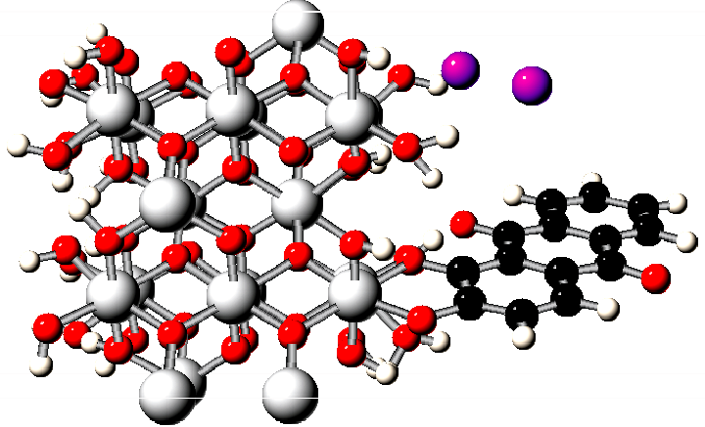
Photoinduced charge separation across molecular/bulk interfaces drives the dye-sensitized semiconductor solar cell. A subject of active research, it creates many challenges due to the stark differences between the quantum states of molecular and periodic systems, as well as the different sets of theories and experimental tools used by physicists and chemists.

Our time-domain atomistic simulations create a detailed picture of these materials. By comparing and contrasting their properties, we provide a unifying description of quantum dynamics on the nanometer scale, resolve several highly debated issues, and generate theoretical guidelines for development of novel systems for energy harvesting and storage.

References

- O. V. Prezhdo “Photoinduced dynamics in semiconductor quantum-dots: insights from time-domain ab initio studies”, Acc. Chem. Res., in press.
- O. V. Prezhdo, W. R. Duncan, V. V. Prezhdo, “Photoinduced electron dynamics at semiconductor interfaces: a time-domain ab initio prospective”, Prog. Surf. Science, 84, 39 (2009)
- O. V. Prezhdo, “Multiple excitons and electron-phonon bottleneck in semiconductor quantum dots: Insights from ab initio studies”, Chem. Phys. Lett. – Frontier Article, 460, 1 (2008).
- O. V. Prezhdo, W. R. Duncan, V. V. Prezhdo, “Dynamics of the photoexcited electron at the chromophore-semiconductor interface”, Acc. Chem. Res., 41, 339 (2008).
- W. R. Duncan, O. V. Prezhdo, “Theoretical studies of photoinduced electron transfer in dye-sensitized TiO₂”, Review, Ann. Rev. Phys. Chem., 58, 143 (2007).
- S. A. Fischer, W. R. Duncan, O. V. Prezhdo, “Ab initio nonadiabatic molecular dynamics of wet-electrons on the TiO2 surface”, J. Am. Chem. Soc., in press.
- Kim H.-D., A. B. Madrid, O. V. Prezhdo, “Symmetric band structure and asymmetric ultrafast electron-hole relaxation in silicon and germanium quantum dots: time-domain ab initio simulation”, Dalton Transact., Solar Energy Conversion, in press.
- A. B. Madrid, H.-D. Kim, O. V. Prezhdo, “Phonon-induced dephasing of excitons in silicon quantum dots: multiple exciton generation, fission and luminescence”, ACS-Nano, 3, 2487 (2009).
- C. M. Isborn, O. V. Prezhdo, “Quantum dot charging quenches multiple exciton generation: first-principles calculations on small PbSe clusters”, J. Phys. Chem. C, available online.
- S. V. Kilina, D. S. Kilin, O. V. Prezhdo, “Breaking the phonon bottleneck in PbSe and CdSe quantum dots: time-domain density functional theory of charge carrier relaxation”, ACS-Nano, 3, 93 (2009).
- C. M. Isborn, S. V. Kilina, X. Li, O. V. Prezhdo, “Generation of multiple excitons in PbSe and CdSe quantum dots by direct photoexcitation: first-principles calculations on small PbSe and CdSe clusters”, J. Phys. Chem. C, 112, 18291 (2008).
- W. R. Duncan, O. V. Prezhdo, “Temperature independence of the photoinduced electron injection in dye-sensitized TiO2 rationalized by ab initio time-domain density functional theory”, J. Am. Chem. Soc., 130, 9756 (2008).
- D. S. Kilin, O. V. Prezhdo, Y. Xia, “Shape-controlled synthesis of silver nanoparticles: Ab initio study of preferential surface coordination with citric acid”, Chem. Phys. Lett., 458, 113 (2008).
- H. Kamisaka, S. V. Kilina, K. Yamashita, O. V. Prezhdo “Ab Initio study of temperature and pressure dependence of energy and phonon-induced dephasing of electronic excitations in CdSe and PbSe quantum dots”, J. Phys. Chem. C., 112, 7800 (2008).
- B. F. Habenicht, H. Kamisaka, K. Yamashita, O. V. Prezhdo, “Ab initio study of vibrational dephasing of electronic excitations in semiconducting carbon nanotubes”, Nano Lett. 7, 3260 (2007).
- W. R. Duncan, C. F. Craig, O. V. Prezhdo, “Time-domain ab initio study of charge relaxation and recombination in dye-sensitized TiO₂”, J. Am. Chem. Soc., 129 8528 (2007).
- S. V. Kilina, C. F. Craig, D. S. Kilin, O. V. Prezhdo, “Ab initio time-domain study of phonon-assisted relaxation of charge carriers in a PbSe quantum dot”, J. Phys. Chem. C 111 4871 (2007).
- H. Kamisaka, S. V. Kilina, K. Yamashita and O. V. Prezhdo, “Ultrafast vibrationally-induced dephasing of electronic excitations in PbSe quantum dots”, Nano Lett., 6, 2295 (2006).
- C. F. Craig, W. R. Duncan, O. V. Prezhdo “Trajectory surface hopping in the time-dependent Kohn-Sham theory for electron-nuclear dynamics”, Phys. Rev. Lett., 95 163001 (2005).
- W. R. Duncan, W. Stier, O. V. Prezhdo, “Ab initio nonadiabatic molecular dynamics of the ultrafast electron injection across the alizarin-TiO2 interface”, J. Am. Chem. Soc., 127 7941 (2005).
- W. R. Duncan, O. V. Prezhdo, “Electronic structure and spectra of catechol and alizarin in gas phase and attached to TiO₂”, J. Phys. Chem. B, 109 365 (2005).
- W. Stier, W. R. Duncan, O. V. Prezhdo, “Thermally assisted sub 10 fs electron transfer in dye-sensitized nanocrystalline TiO₂ solar cells”, Adv. Mat., 16 240 (2004).
- W. Stier and O. V. Prezhdo, “The effect of thermal fluctuations on the light-induced electron transfer from an anchored molecular electron donor to a semiconductor acceptor”, Isr. J. Chem. 42 213-224 (2003).
- W. Stier and O. V. Prezhdo, “Non-adiabatic molecular dynamics simulation of light-induced electron transfer from an anchored molecular electron donor to a semiconductor acceptor”, J. Phys. Chem. B, 106 8047 (2002).

